MongoDB Assignmnet

5) Connect to MongoDB database through the MongoDB shell command line interface

Ans :-

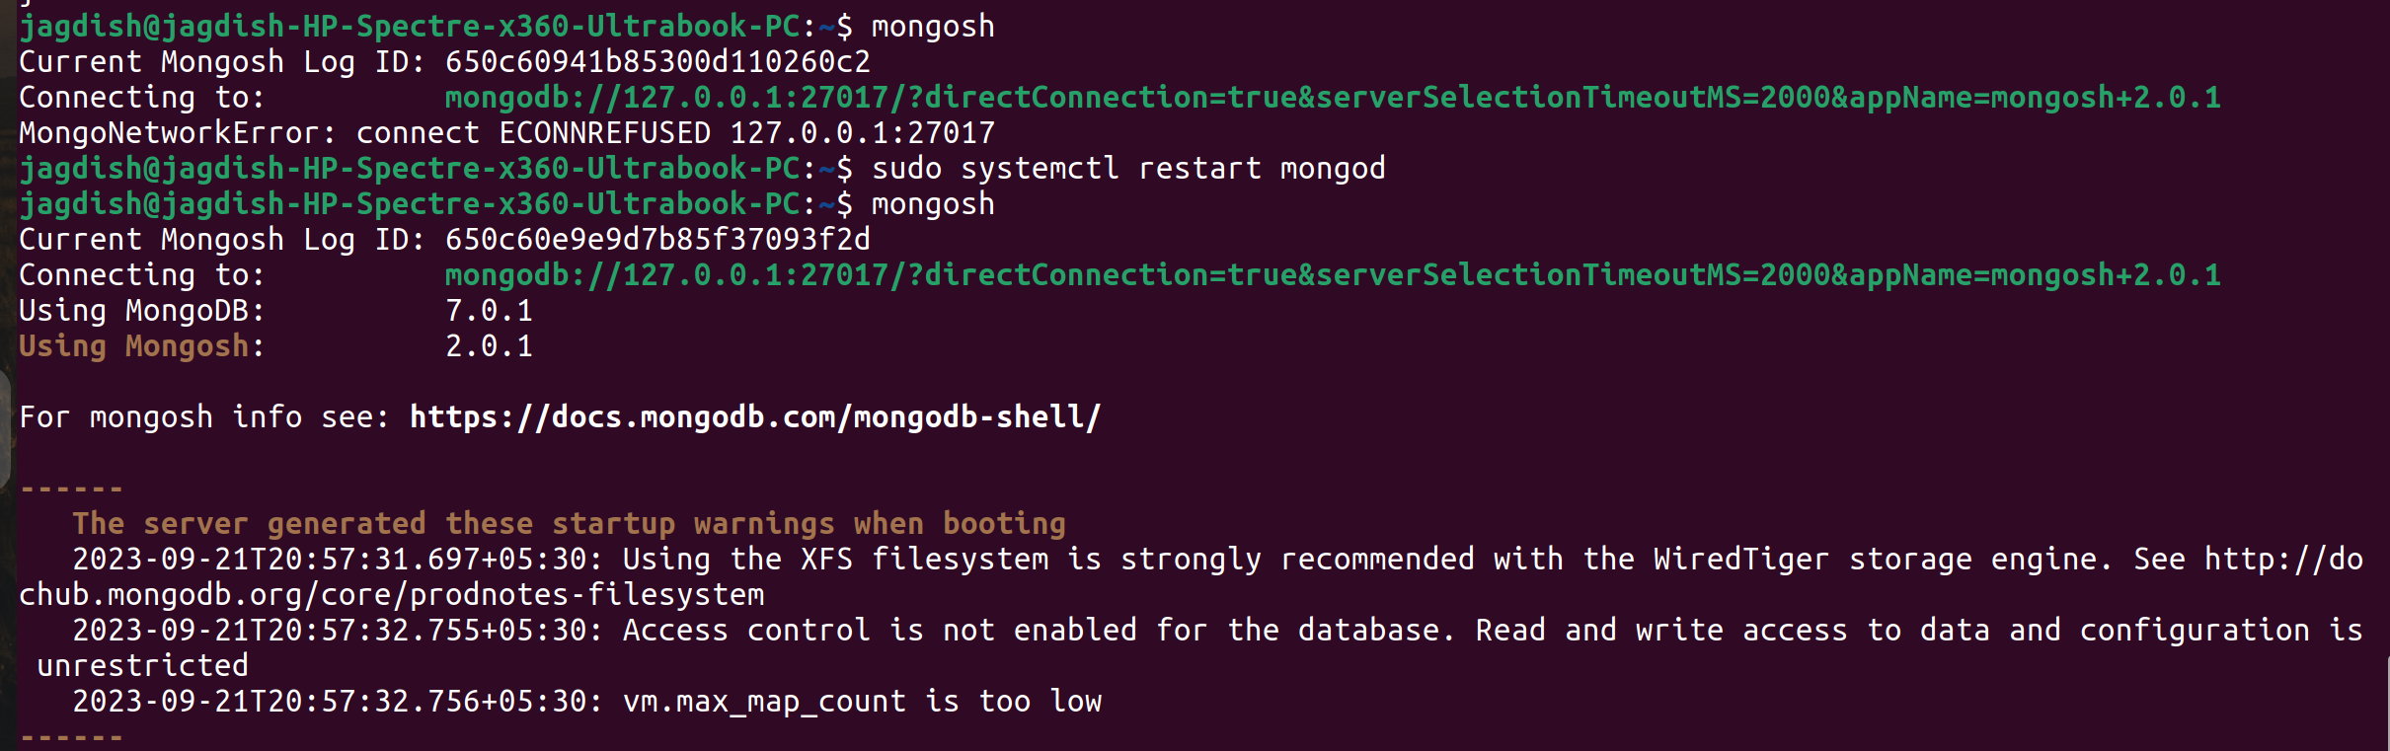

6) View list of available databases

Ans : -

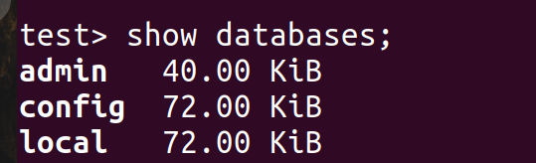
7. Create a new database named CDAC and connect to it
Ans :-
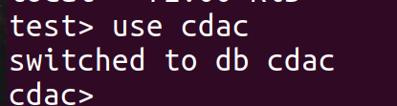

8. View list of available collections in CDAC database

Ans :-

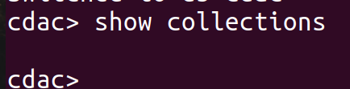
9. Create a new collection by the name of LIBRARY

Ans : -

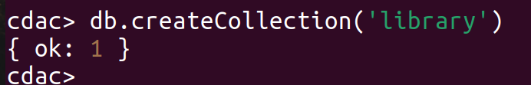
10. Insert the following document in the LIBRARY collection:-
title:'MongoDB programming', author:'Sameer', likes:100

Ans :-
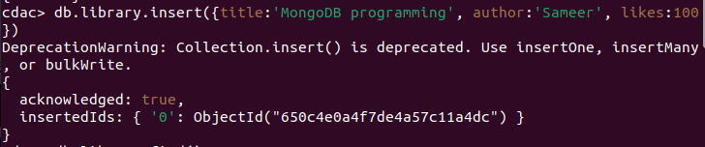

11. View the recently inserted document and note the _id field

Ans : -

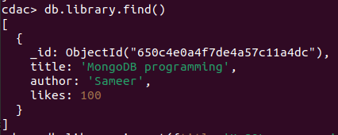
12) Insert another document in the LIBRARY collection as follows:-
title:'MySQL programming', authors:['Jack','Jill'], likes:200

Ans :-

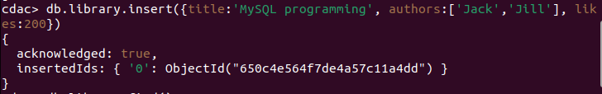
13) View the inserted documents

Ans :-
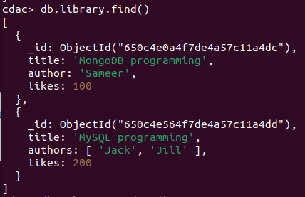
14) View only the first inserted document

Ans: -

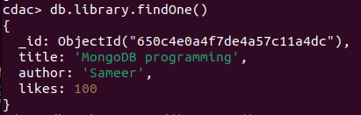
15)View the documents using the pretty() method
Ans :-

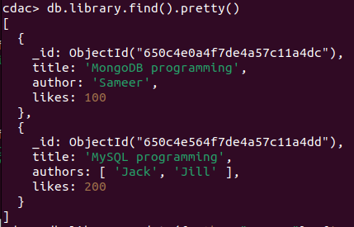

16) Update the document where author name = Sameer and change it to Sameer Dehadrai

Ans :-

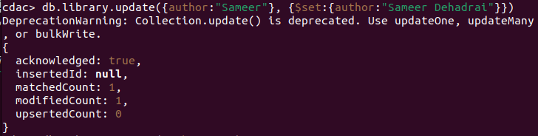
17) Delete all documents that have 100 likes

Ans :-

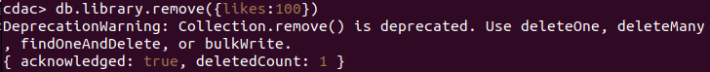
18) Drop the LIBRARY collection

Ans :-
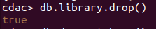

`

19. Drop the CDAC database

Ans :-

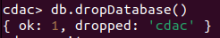
20. Exit from MongoDB shell

Ans :-

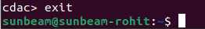
21 Stop MongoDB server

Ans :-

